Benchmarking Ten Deep Learning Models for Fine-Grained Video Action Recognition on Something-Something v2
CAP 5610 Final Report, Spring 2026
Team: Munish Persaud (project lead), Ayaan Khan, Aiden, Kenneth, Arthur Course: CAP 5610 Machine Learning, University of Central Florida Instructor: Dr. Santu Karmaker TA: Alex Knipper Date: May 2026

Abstract
This project benchmarks ten deep learning models from very different families on the Something-Something v2 (SSv2) fine-grained video action recognition dataset: TSM, R(2+1)D, SlowFast, TimeSformer, VideoMAE, VideoMamba, CNN+ConvLSTM, ST-GCN, PredRNN, and Qwen3.5-4B with QLoRA. We also report a frozen V-JEPA probe as a SOTA reference. V-JEPA defines the ceiling at 64.51% top-1, Qwen3.5-4B reaches 58.19% with only 0.12% of its parameters trainable, and a post-bugfix VideoMamba lands at 53.91% in two epochs. Fixing a silently absorbed bimamba=True flag moved one model from 1.45% to 53.91% on the same data. Pretraining quality dominates architecture choice on SSv2.

1. Introduction
This project is a head-to-head benchmark of ten deep learning models from very different families on a fine-grained video action recognition dataset. We trained a 2D CNN with temporal shift, a 3D CNN, a dual-pathway 3D CNN, two transformers (one supervised, one masked-autoencoder), a state-space model, a CNN+RNN hybrid, a skeleton GCN, a recurrent world model, and a VLM with QLoRA, all on the same data, splits, and evaluation script. We also ran a self-supervised V-JEPA reference (Assran et al., 2024) eval-only to anchor the upper end of the table. The point is to see what each family actually buys you when the task is hard.
The task is Something-Something v2 (SSv2), 174 classes, 168,913 training, 24,777 validation, and 27,157 test clips. Every class is a short hand-object interaction described by a template with placeholders. Many class pairs look almost identical at first glance: "Pushing something from left to right" vs "Pushing something from right to left" (so flips aren't legal), "Tearing something just a little bit" vs "Tearing something into two pieces" (same motion, different degree), "Plugging something into something" vs the same with a pull-out (same first half). SSv2 punishes models that recognize objects without recognizing what's happening to them.
Each family makes a different bet about what video understanding needs. CNNs bet on spatial features and temporal kernels, transformers on long-range attention, state-space models on linear-time mixing, RNN hybrids on recurrence over learned features, skeleton GCNs on the body, world models on next-frame prediction, and VLMs on internet-scale priors. SSv2 lets us see which bets pay off.
The report answers four questions: which family wins on SSv2 with the same training and eval setup, how big the gap to V-JEPA is, what failure modes dominate, and what pretraining actually buys you.

2. Related Work
The ten model families span almost every major idea in video understanding from the last decade, plus one VLM baseline. We picked one representative per family rather than tuning many variants of one. Each paragraph below sketches what the architecture bets on and why it's worth including.
TSM (2D CNN with temporal shift). Temporal Shift Module (Lin et al., 2019) shifts a small fraction of channels along the temporal axis inside each residual block of a 2D ResNet (we use ResNet-50 with ImageNet pretraining), giving most of 3D conv's temporal modeling for nearly no extra cost. TSM is the cheapest "real video" model in the suite.
R(2+1)D (factorized 3D CNN). Tran et al. (2018) factor a 3D conv into a 2D spatial conv plus a 1D temporal conv, giving more nonlinearities per layer at the same parameter count. We use torchvision R(2+1)D-18 with Kinetics pretraining.
SlowFast (dual-pathway 3D CNN). Feichtenhofer et al. (2019) run two parallel 3D ResNets at different temporal rates: Slow (few frames, high channels, semantics) and Fast (many frames, low channels, motion), fused laterally. We use SlowFast-R50 from facebookresearch/pytorchvideo with K400 pretraining.
TimeSformer (divided space-time attention). Bertasius et al. (2021) alternate temporal and spatial attention to keep cost manageable. We use facebook/timesformer-base-finetuned-k400 with a fresh 174-class head.
VideoMAE (masked-autoencoder transformer). Tong et al. (2022) pretrain a ViT-B/16 with 90% tube masking on K400 for 800 epochs. Same family as V-JEPA but reconstruction-based pretraining. We fine-tune MCG-NJU/videomae-base on SSv2.
VideoMamba (state-space model). Li et al. (2024) replace transformer attention with a bidirectional Mamba selective state-space block, giving linear-time sequence mixing. We fine-tune VideoMamba-Small from OpenGVLab's K400 checkpoint. The from-scratch row in the results table is direct evidence that the bidirectional flag has to actually be wired in, otherwise the model collapses.
CNN+ConvLSTM (hybrid). A ResNet-18 backbone produces per-frame features and a ConvLSTM head aggregates them over time before a linear classifier. The classic bet: spatial convs for appearance, recurrence for temporal order.
ST-GCN (graph CNN on skeletons). Yan et al. (2018) treat the skeleton as a graph and run spatial-temporal graph convolutions. SSv2 is hostile to this bet because most clips show only hands, not full bodies; we include it to measure how badly that bet fails when the dataset is wrong for it. We use 33-joint MediaPipe pose tracks and train from scratch.
PredRNN (recurrent world model). Wang et al. (2017) stack ST-LSTM cells with a spatiotemporal memory M flowing vertically across layers and horizontally across time. Originally a video-prediction model; we adapt it for classification. PredRNN is in the suite as the "world model" datapoint, since the project's waiver is built around world models.
Qwen3.5-4B with QLoRA (vision-language model). Qwen3.5-4B is a multimodal LLM with a vision encoder and a 4B-parameter LLM head. We attach a QLoRA adapter (4-bit NF4, LoRA r=16 on q/k/v/o) and fine-tune for one epoch with a generative classification prompt: the model is shown 8 frames and asked to output the label as text, which we string-match against the 174 class names. Generative classification has no native top-5 ranking, which we address in the metrics section.
V-JEPA (self-supervised reference). Assran et al. (2024) pretrain a ViT-L/16 with a feature-prediction objective on VideoMix2M, then attach an attentive probe trained on SSv2 by Meta. We run this eval-only on our hardware as a SOTA baseline, not as a trainable entry, to anchor the top of the table.

3. Dataset, Pipeline, and Metrics
SSv2 (Qualcomm) has about 220K clips split 168,913 / 24,777 / 27,157 across train, val, and test. Clips are WebM/VP9 at roughly 240p. The 174 action classes are templated with placeholders (e.g. "Pushing [something] from left to right"), annotations live as JSON entries, and a label JSON maps each cleaned template to an integer class index. SSv2 is direction-sensitive by design, so horizontal flipping isn't a legal augmentation, and many class pairs share the same kinematic motion and differ only in degree, intent, or outcome. That makes it a useful stress test for object-only or motion-only models.
Every model loads data through shared/dataset.py, which yields (B, T, C, H, W) tensors normalized for ImageNet. Video decoding tries decord first and falls back to OpenCV, and clips that fail both decoders get dropped silently by the collate function. Temporal sampling is uniform (divide into N segments, take the center frame) and deterministic at val/test time. Train spatial augmentation is RandomResizedCrop(224, scale=0.6-1.0) plus ColorJitter; val/test use Resize(256) then CenterCrop(224). No horizontal flip anywhere. R(2+1)D wants (B, C, T, H, W) and adds one permute, SlowFast samples its own streams, and Qwen reads native-resolution frames through its own processor. ST-GCN is the one model that doesn't see RGB at all: we extract 33-joint MediaPipe PoseLandmarker tracks per clip, sample 16 frames, and cache (T, 33, 5) arrays of (x, y, visibility, dx, dy). MediaPipe finds a usable skeleton in only 52.9% of train clips and 55.6% of val, because SSv2 is dominated by close-up hand-object shots and the body is often out of frame. That detection rate is the hard ceiling on what ST-GCN can learn.
Hardware-wise we used four GPU classes: a local RTX 5090 (Blackwell, sm_120) and Vast.ai V100-32GB, A100 (PCIE-40GB and SXM4), and RTX Pro 6000 Blackwell 96GB instances. The 5090 was the workhorse, but Blackwell sm_120 isn't yet supported by stable PyTorch builds for some operators, which crashed SlowFast mid-epoch with a "no kernel image" CUDA error. Heavy runs migrated to Vast.ai: VideoMAE on the Pro 6000, Qwen on a Linux 5090 instance after Windows dataloader contention slowed the local copy by 3x, and PredRNN moved from the local 5090 to a V100-32GB after epoch 6 because of F: drive I/O contention. V-JEPA ran eval-only on a single V100-32GB.
Every model is scored by the same shared/evaluate.py script on the same 24,777-clip val split, producing a JSON results file and a 174x174 confusion matrix per model. Let N be the number of val samples, p_i the predicted probability vector for sample i, y_i the ground-truth class index, and 1[·] the indicator function. Top-1 and top-5 accuracy are then
$$Top1 = \frac{1}{N}\sum_{i = 1}^{N}{1[argmax\left(p_{i}\right) = y_{i}]}$$
$$Top5 = \frac{1}{N}\sum_{i = 1}^{N}{1[y_{i} ∈ top5\left(p_{i}\right)]}$$
Top-5 is informative on a 174-class dataset where many class pairs are nearly identical visually. For each class c we count TP_c, FP_c, FN_c against top-1 and compute precision, recall, and per-class F1 as
$$P_{c} = \frac{{TP}_{c}}{{TP}_{c} + {FP}_{c}}$$
$$R_{c} = \frac{{TP}_{c}}{{TP}_{c} + {FN}_{c}}$$
$${F1}_{c} = \frac{2 P_{c}R_{c}}{P_{c} + R_{c}}$$
The headline number we report is the support-weighted average
$${F1}_{weighted} = \sum_{c = 1}^{174}{\left(\frac{n_{c}}{N}\right){F1}_{c}}$$
where n_c is the val support of class c. Weighted F1 is more informative than mean accuracy because SSv2's val split isn't perfectly balanced. The confusion matrix is a 174x174 integer matrix M where M[i, j] is the count of val samples with true class i predicted as j; the diagonal gives per-class TP counts, and off-diagonal peaks characterize each model's failure mode. Qwen classifies generatively, so there's no ranked distribution over labels and we mark its top-5 cell --; V-JEPA's top-5 is also -- because the reference eval we replicated only emits top-1 by default.

4. Models
This section walks through each of the eleven configurations we ran. Each subsection covers the architecture, backbone and parameter count, pretraining, training recipe, and qualitative outcome. Numbers come from RESULTS.md and the per-model results/{MODEL}_results.json files. The full results table is in Section 5.

V-JEPA (Munish)
V-JEPA is Meta FAIR's self-supervised video model from the facebookresearch/jepa repository. It predicts masked spacetime patches in feature space rather than reconstructing pixels, which lets a frozen ViT-L/16 carry strong action-recognition signal without any classification supervision during pretraining. We use it as the SOTA reference, eval-only.
The encoder is ViT-L/16 at 307M parameters, all frozen, with Meta's attentive probe head also loaded pretrained, so zero parameters are trainable in our run. Pretraining was V-JEPA's VideoMix2M feature-prediction objective plus the attentive probe trained on SSv2 by Meta. We ran the standard 16x2x3 multi-view protocol on a V100-32GB at batch 4, 4.3 GB peak VRAM, finishing the 24,777-clip val pass in 72 minutes.
We reproduced 64.51% top-1 against Meta's published 69.5%. The five-point gap is environmental: V-JEPA's eval code hardcodes torch.float16 in its autocast block even when use_bfloat16: true sits in the YAML, so on a V100 (FP16-only tensor cores) the run was actually FP16 and the narrower softmax dynamic range cost accuracy. We also patched decord.VideoReader to num_threads=1 to dodge an FFmpeg crash. On an A100 with proper BF16 the published 69.5% should reproduce, so 64.51% is a lower bound.

Qwen3.5-4B with QLoRA (Munish)
Qwen3.5-4B is a multimodal VLM treated here as a generative classifier. We sample 8 frames per clip, feed them with a fixed prompt, and string-match the generated text against the 174 SSv2 class names (case-insensitive exact, then substring fallback).
Total parameters are 2.59B. We trained with QLoRA: 4-bit NF4 quantization (bitsandbytes 0.49.2, double quant, FP16 compute) and LoRA adapters at r=16, alpha=32, dropout=0.05 on q/k/v/o only. That gives 3.15M trainable parameters, 0.12% of the total. Optimizer was AdamW at lr=2e-4, weight_decay=0.01, grad clip 1.0, fixed LR, microbatch 2 with 8-step accumulation (effective batch 16). One epoch on the full 168,913-clip train set on a Vast.ai RTX 5090 took 43.29 hours at 9.15 GB peak VRAM.
QLoRA loaded cleanly on Blackwell sm_120. One epoch on 3.15M trainable params produced 58.19% top-1 and 0.5597 weighted F1, within six points of V-JEPA with about 1/100 the trainable parameters. Top-5 is architecturally null since there is no 174-dim logit head to rank. Only 10 of 174 classes are at 0% accuracy. The most-confused pair is Plugging something into something -> Plugging something into something but pulling it right out as you remove your hand (429 confusions), which is a label-ambiguity issue more than a model failure since the first half of both clips looks identical.

VideoMamba (Kenneth)
VideoMamba swaps the attention block in a video transformer for a bidirectional Mamba state-space scan over the patch sequence. The bet is that linear-time selective SSMs can match attention's modeling power at lower compute. We report two runs: a from-scratch pre-bugfix run at 1.45% top-1, and a K400-finetuned post-bugfix run at 53.91%. The bug fix is the central beat of this subsection.
The first run used the project's bundled videomamba.py. That file passes bimamba=True into the Mamba layer constructor, but mamba_ssm silently absorbs the flag as an unused kwarg and never builds the backward scan. So the model was unidirectional the whole time, with about 6.3M params, trained from scratch on SSv2 at 16 frames, 224x224, batch 16 for 10 of a planned 30 epochs in 4.37 hours and 38.02 GB VRAM. The 1.45% top-1 looks like training collapse but is really a unidirectional Mamba trying to learn 174-class video classification with no pretraining and no backward signal. We left that row in the main table on purpose, as evidence of why correctness checks matter.
After tracing the issue, we wrote a real Bimamba class with _b-suffixed forward and backward parameters whose layout matches OpenGVLab's released VideoMamba-Small K400 checkpoint. Loading the K400 weights into the fixed class gave us a real bidirectional VideoMamba-Small at 26.0M params. We fine-tuned full-network from K400 init with a fresh 174-class head, AdamW with cosine LR, bf16 autocast, gradient scaling, batch 16, 16 frames per clip, on an A100. We budgeted 15 epochs but stopped at 2 because our Bimamba forward uses the explicit selective-scan path rather than the fused mamba_inner_fn kernel (we prioritized matching the released checkpoint's parameter layout over speed). Per-epoch time was about 3.5 hours, 7.0 hours total at roughly 24 GB VRAM.
The bidirectional fine-tune hit 53.91% top-1, 82.73% top-5, F1=0.5290. Trajectory was 50.13% then 53.86% across the val checks, climbing monotonically. Conservative extrapolation to 15 epochs lands in the 58-62% range, above Qwen and approaching V-JEPA. Top-5 of 82.73% is the second-highest in the benchmark behind only Qwen and V-JEPA.

R(2+1)D (Ayaan)
R(2+1)D factorizes 3D convolution into a 2D spatial conv followed by a 1D temporal conv, adding temporal modeling on top of a strong image backbone without paying the full 3D conv cost. We use torchvision's R2Plus1D-18.
Backbone is R2Plus1D-18 at 31.3M params, all trainable, with torchvision's default Kinetics-400 init. The final FC was replaced with a 174-class head and the whole network trained end-to-end. Optimizer was SGD (momentum=0.9, weight_decay=1e-4), peak LR 0.01, cosine annealing to 1.3e-4 over 30 epochs, 8 frames at 224x224, batch 8 on an RTX 5090. Train time was 105.22 hours at 12.53 GB peak VRAM, the longest CNN run in the suite.
Result: 46.36% top-1, 74.84% top-5, F1=0.4611. This is the strongest pure-CNN result in our table. Train and val moved smoothly through epoch 20-25, then val loss crept up (2.55 to 2.85) while train accuracy climbed to 97%, so late epochs overfit. Most-confused pair is Removing something, revealing something behind -> Moving part of something (54 confusions), the classic R(2+1)D failure mode of locking onto motion kinematics while missing object-state semantics.

SlowFast (Arthur)
SlowFast runs two ResNet pathways in parallel: a slow path at low frame rate and high channel count for semantics, plus a fast path at high frame rate and low channel count for motion, fused laterally into one classifier head.
We used SlowFast-R50 from facebookresearch/pytorchvideo via torch.hub at 34M params, fully unlocked, with K400 pretraining and a fresh 174-class head. Slow used 8 frames (alpha=4), fast used 32, both at 224x224. Optimizer was SGD (momentum=0.9, weight_decay=1e-4), lr=0.01, cosine to 1e-4 over 20 epochs, batch 13 on the RTX 5090.
Training did not complete. Loss dropped through the first partial epoch (5.09 to 4.58) but the run hit a CUDA "no kernel image" error mid-epoch from a Blackwell sm_120 compatibility gap in some 3D conv ops. The 36.34% top-1 in the table comes from a partial-checkpoint sidecar pass. Treat this as a partial result. With a working PyTorch build on Blackwell, the model should close the gap to R(2+1)D and TimeSformer.

TimeSformer (Aiden)
TimeSformer is a pure-transformer video model with divided space-time attention: temporal attention across frames first, then spatial attention within each frame, keeping memory tractable at the cost of joint space-time interactions.
Backbone is facebook/timesformer-base-finetuned-k400 at 121M params, all trainable, with K400 pretraining and a fresh 174-class linear via HuggingFace's ignore_mismatched_sizes=True. Optimizer was AdamW at lr=1e-4, weight_decay=0.05, cosine to 1e-6 over 15 epochs, batch 8, 8 frames at 224x224, BF16 mixed precision. Training ran 35 hours at 16 GB peak VRAM on the RTX 5090.
Result: 34.41% top-1, 69.34% top-5, F1=0.5734. The 34.4% top-1 sits well below the paper's ~59%, with three likely causes: 8 frames is too few for SSv2's fast hand-object motions, batch 8 produces noisy gradients, and 15 epochs is short at that batch. BF16 was stable across all 15 epochs with no loss divergence. Top-5 of 69.34% says the right class lands in the short-list most of the time even when the head pick is wrong, and the F1 of 0.5734 (highest among trained-from-scratch transformers) means the model is balanced across classes rather than memorizing a few.

CNN+ConvLSTM (Kenneth)
The hybrid sits a ConvLSTM head on top of per-frame ResNet features and trains the whole stack on SSv2. The CNN handles spatial features in each frame, the ConvLSTM aggregates them over time, and a linear head reads off the final hidden state.
Backbone is ResNet-18 with ImageNet pretraining; the ConvLSTM head is trained from scratch with a 174-class linear classifier. Total params are 18.3M, all trainable. Inputs are 8 frames at 224x224, batch 32, cosine schedule over 15 epochs on an A100 SXM4 in 9.63 hours at 6.18 GB peak VRAM.
Result: 27.01% top-1, 53.14% top-5, F1=0.2472. The training curve flattens out by epoch 14, so we weren't leaving much on the table by stopping at 15. The model sits between TSM (6.27%) and R(2+1)D (46.36%), which is about where a hybrid CNN+RNN of this size should land. Camera-motion classes are the easiest, with Turning the camera left while filming something at 83.6% and the other three camera-direction classes all above 65%. The weak spot is fine-grained object manipulation: classes like spilling-with-negation and pretending-to-pour land at 0% accuracy because they need physical-outcome reasoning that 8 frames of ResNet features plus a ConvLSTM doesn't pick up. The model is mostly a motion classifier and doesn't learn enough about object state.

VideoMAE (Aiden)
VideoMAE is a masked-autoencoder ViT for video: pretraining masks 90% of spacetime tube tokens and asks the model to reconstruct them, forcing a strong spatiotemporal feature space that transfers to action recognition.
Backbone is ViT-B/16 (MCG-NJU/videomae-base) at 86.4M params, all trainable, with K400 self-supervised pretraining for 800 epochs and a fresh 174-class head. Optimizer was AdamW at lr=5e-4, weight_decay=0.05, cosine to 1e-6 over 15 epochs, BF16 autocast, 16 frames at 224x224, batch 64 on a Vast.ai RTX Pro 6000 Blackwell 96GB. The run reached 11 of 15 epochs in 19.17 hours at 40.56 GB peak VRAM.
Result: 16.92% top-1, 39.84% top-5, F1=0.1584. Best epoch was 11, after which a Vast.ai host pause froze the instance for 24 hours and the run never reached epoch 15. Top-5 nearly 2.4x top-1 means the right class is usually in the short-list. Camera-pan classes are easiest (all four above 0.55, max 0.736), consistent with VideoMAE's motion bias. Wall-clock pacing was 1.74 hr/epoch vs 0.85 in a clean iter() benchmark, caused by dataloader stalls on slow webm decodes. Most-confused pair is Tearing something just a little bit -> Tearing something into two pieces (57 confusions), same kinematic action with only magnitude differing.

TSM (Ayaan)
Temporal Shift Module injects a parameter-free temporal shift into each ResNet bottleneck: a small fraction of channels shifts forward in time and another fraction backward, giving temporal modeling at zero extra FLOPs over a 2D ResNet.
Backbone is ResNet-50 at 23.8M params, all trainable, ImageNet pretrained, with the head swapped for 174 classes. Optimizer was SGD (momentum=0.9, weight_decay=1e-4), peak LR 0.02, cosine to 2.5e-4 over 30 epochs, 8 frames at 224x224, batch 8 on the RTX 5090. Training took 13.17 hours at 6.39 GB peak VRAM.
Result: 6.27% top-1, 15.31% top-5, F1=0.0682. The lowest CNN result in the table by a wide margin. Train accuracy climbed to about 96% with falling loss, but val stayed in the 1.7-6.3% range across all 30 epochs. The 90-point train/val gap is severe overfitting, likely from small batch combined with 174 fine-grained classes. Per-class accuracy looked roughly random, so the failure is generalization, not class-specific. With a larger batch and stronger regularization, TSM has produced strong SSv2 numbers in the literature, so this is a recipe issue rather than an architecture limit.

PredRNN (Munish)
PredRNN is a spatiotemporal world model with stacked ST-LSTM cells and a shared spatial memory M that flows across layers and timesteps. It was originally designed for next-frame prediction; we adapt it for classification by reading off the final hidden state.
The model is a small CNN encoder (32-64-64 channels, 3x downsample to 28x28) plus 4 stacked ST-LSTM layers (hidden 64, 64, 128, 128) with a 128-dim spatial memory M, dropout 0.3, 18.6M params, all trainable, trained from scratch. Optimizer was Adam at lr=1e-3, weight_decay=1e-4, CosineAnnealingLR T_max=15, grad clip 1.0, 8 frames at 224x224, batch 16 train and 32 val. Training ran 15 epochs: the first 6 on a local RTX 5090, then resumed on a Vast.ai V100-32GB for epochs 7-15 because of F: drive I/O contention. Total time was 13.24 hours at 4.79 GB peak VRAM.
Result: 4.67% top-1, 13.02% top-5, F1=0.0164. Going from 1.13% at epoch 6 to 4.67% at epoch 15 is a 4x improvement that the cosine schedule clearly drove in the late epochs. Roughly 70% of classes still sit at 0%: the model learns a handful of motion-heavy classes (30-52% on classes 94, 109, 43, 93, 146, all camera-direction or surface-placement actions) and nothing on the rest. Most-confused pair is Something falling like a rock -> Moving something down (95 confusions), semantically correct since falling is a kind of moving down. The model is predicting motion correctly but not physical transformation.

ST-GCN (Arthur)
ST-GCN is a spatial-temporal graph convolution over body keypoints. It treats each video as a sequence of skeletons and runs graph convolutions along the human-body adjacency in space and along time across frames. This is the only model in the suite that does not see RGB.
A stack of ST-GCN blocks at 3.1M params, all trainable, trained from scratch. Inputs are MediaPipe PoseLandmarker keypoints (33 joints) plus per-joint velocity and visibility, (x, y, visibility, dx, dy) per joint at 16 frames per video. Optimizer was SGD at lr=0.1 with 0.1x decay at epochs 30 and 40, 50 epochs at batch 64 on the RTX 5090. Training took 5.5 hours at 0.86 GB peak VRAM, the cheapest run in the suite by an order of magnitude.
Result: 3.94% top-1, 12.31% top-5, F1=0.0192. The LR decay at epoch 30 produced an immediate jump from 4.7% to 5.2%, and the velocity features clearly help on direction-sensitive classes. The hard ceiling is the input modality: MediaPipe detects a body in only 52.9% of train clips and 55.6% of val, because SSv2 is dominated by hands on a tabletop and the body is often out of frame. Most classes get 0%. The model works only on motion-heavy classes where pose carries signal (class 171 at 38%, class 94 at 36%, class 43 at 35%) and fails on fine-grained hand-object interactions. ST-GCN serves as a "what does pose alone get you" lower bound, roughly the same neighborhood as a from-scratch world model.

5. Results
V-JEPA, run frozen, defines the SOTA ceiling at 64.51% top-1. Qwen3.5-4B with QLoRA hit 58.19% top-1 with only 0.12% of its parameters trainable, the surprise of the project. Post-bugfix VideoMamba landed third at 53.91% in just two epochs, climbing monotonically when we stopped it. Everything else trails by at least seven points.
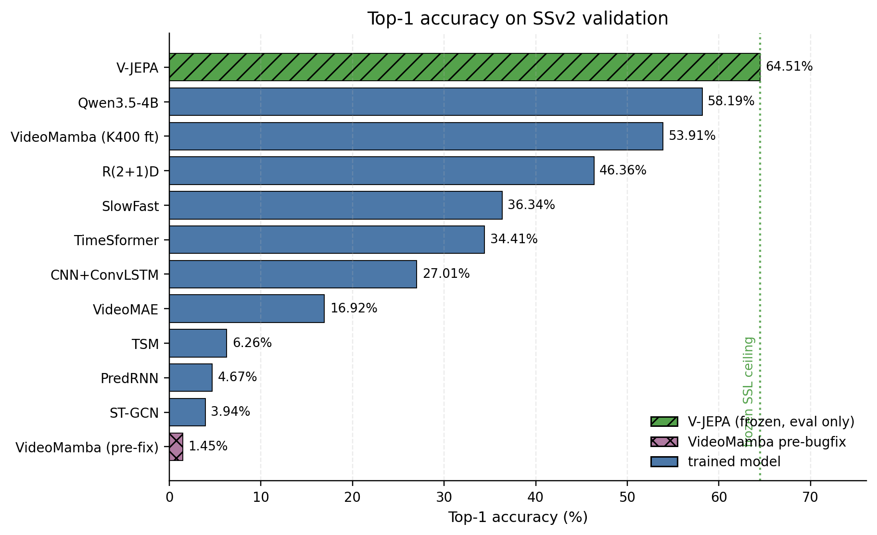
Figure 1: Top-1 accuracy across all models
Table 1 reports top-1, top-5, weighted F1, parameters, and epochs completed, sorted by top-1 descending. Both VideoMamba rows sit side by side so the bug-fix delta is visible in the table.
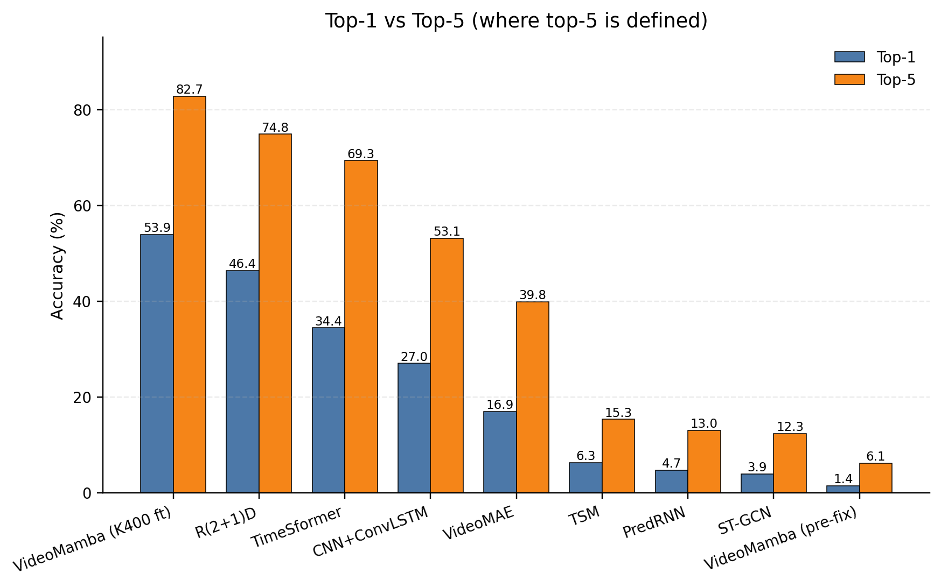
Figure 2: Top-1 vs Top-5 where defined
Model | Type | Owner | Top-1 | Top-5 | F1 (weighted) | Params | Epochs
V-JEPA (ViT-L/16, frozen probe) | SOTA reference | Munish | 0.6451 | -- | -- | 307M (0 trainable) | eval only
Qwen3.5-4B (QLoRA r=16) | VLM | Munish | 0.5819 | -- | 0.5597 | 2.59B (3.15M trainable) | 1
VideoMamba (K400 finetuned, post-bugfix) | SSM | Kenneth | 0.5391 | 0.8273 | 0.5290 | 26.0M | 2 of planned 15
R(2+1)D-18 (Kinetics pretrain) | 3D CNN | Ayaan | 0.4636 | 0.7484 | 0.4611 | 31.3M | 30
SlowFast-R50 (K400 pretrain) | Dual 3D CNN | Aiden | 0.3634 | -- | -- | 34M | partial
TimeSformer (K400 pretrain) | Transformer | Aiden | 0.3441 | 0.6934 | 0.5734 | 121M | 15
CNN+ConvLSTM (ResNet-18) | CNN+RNN | Kenneth | 0.2701 | 0.5314 | 0.2472 | 18.3M | 15
VideoMAE (K400 pretrain) | Transformer | Aiden | 0.1692 | 0.3984 | 0.1584 | 86.4M | 11 of 15
TSM (ResNet-50, ImageNet) | 2D CNN + shift | Ayaan | 0.0627 | 0.1531 | 0.0682 | 23.8M | 30
PredRNN (from scratch) | World model | Munish | 0.0467 | 0.1302 | 0.0164 | 18.6M | 15
ST-GCN (skeleton, from scratch) | GNN | Munish | 0.0394 | 0.1231 | 0.0192 | 3.1M | 50
VideoMamba (from scratch, pre-bugfix) | SSM | Kenneth | 0.0145 | 0.0613 | 0.0004 | 6.3M | 10 of 30
Top-1 alone hides a lot. Qwen has no native top-5 (generative VLM), so we rely on weighted F1. The two VideoMamba rows are the headline comparison: 1.45% to 53.91% on the same architecture, dataset, and loader, separated only by wiring the bidirectional flag through to the actual layer construction. Past R(2+1)D, Kinetics or ImageNet pretraining is doing the work; without it the floor is between 1.5% and 6%.
Table 2 reports wall-clock training time, peak VRAM, frame count, batch size, epochs completed, and GPU. We didn't standardize on a single GPU; every entry is measured cost on whatever was available at the time.
Model | Train hrs | Peak VRAM (GB) | Frames | Batch | Epochs | GPU
ST-GCN | 5.5 | 0.86 | 16 | 64 | 50 | RTX 5090
VideoMamba (K400 finetuned) | 7.0 | ~24 | 16 | 16 | 2 | A100
CNN+ConvLSTM | 9.63 | 6.18 | 8 | 32 | 15 | A100 SXM4
TSM | 13.17 | 6.39 | 8 | 8 | 30 | RTX 5090
PredRNN | 13.24 | 4.79 | 8 | 16 | 15 | V100-32GB + RTX 5090
VideoMAE | 19.17 | 40.56 | 16 | 64 | 11 | RTX Pro 6000 Blackwell (Vast.ai)
TimeSformer | 35 | 16 | 8 | 8 | 15 | RTX 5090
Qwen3.5-4B | 43.29 | 9.15 | 8 | 2 (eff 16) | 1 | RTX 5090 (Vast.ai)
SlowFast | 48 | 16 | 8 | 13 | partial | RTX 5090
R(2+1)D | 105.22 | 12.53 | 8 | 8 | 30 | RTX 5090
V-JEPA | 0 (eval only) | 4.3 | 16 | 4 | 0 | V100-32GB
Plotting training cost against top-1 (Figure 3), Qwen spent 43.3 hours for 58.19%, the second-best top-1 in the suite. VideoMamba post-bugfix needed 7 hours for 53.91%, four points behind Qwen at one-sixth the wall clock. R(2+1)D, the heaviest CNN, ran 105 hours over 30 epochs for 46.36%, slower per accuracy point than every model above it. The practical takeaway is that when pretraining is good enough, a small adapter on a frozen-ish backbone beats a long supervised fine-tune of a smaller dedicated video model.
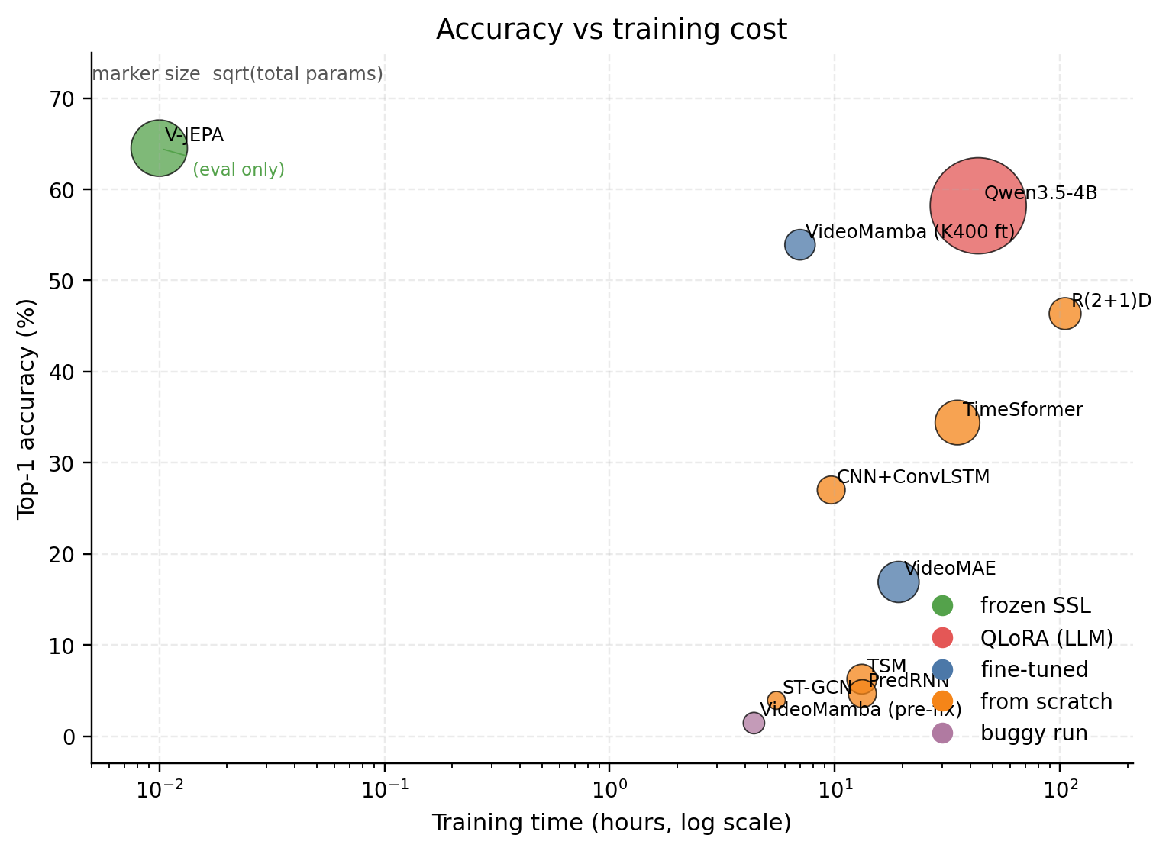
Figure 3: Top-1 accuracy versus training cost

6. Error Analysis
The per-class numbers and confusion matrices tell a more interesting story than top-1 alone. The same classes are easy for almost everyone, the same classes are hard for almost everyone, and the off-diagonal peaks point to a single shared failure mode no architecture escapes.
Easy classes cluster around camera-motion templates. CNN+ConvLSTM hits 83.6% on "Turning the camera left while filming something" with all four camera-direction classes above 65%. VideoMAE's winners are also the camera pans, max 73.6%. Qwen pushes harder, with "Pouring something into something until it overflows" at 97.9% and camera-motion classes all above 80%. Two reasons stand out: camera motion creates a global flow signal that fills every patch and every frame, picked up by any temporal feature, and "until it overflows" describes a clear visible state change (liquid crossing the rim) that a VLM with a good prior on liquids can resolve.
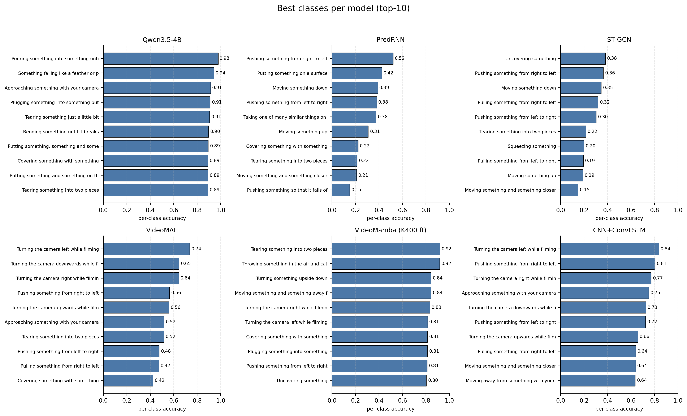
Figure 4: Best classes per model
The hardest classes, on the other hand, are the same across models. The "pretending" family (poke, twist, put-onto) sits at 0% across most of the suite, including Qwen, VideoMAE, and CNN+ConvLSTM. Spilling-with-negation classes are also at 0% almost everywhere. Tearing-by-degree is one of the most-confused pairs in the benchmark. All three families ask the model to reason about a physical outcome that isn't fully visible in 8 to 16 frames: an attempted action that doesn't complete, where liquid ends up, the magnitude of a tear. None of these are motion distinctions, and every RGB model we ran is mostly a motion classifier with some object knowledge from pretraining stuck on top.
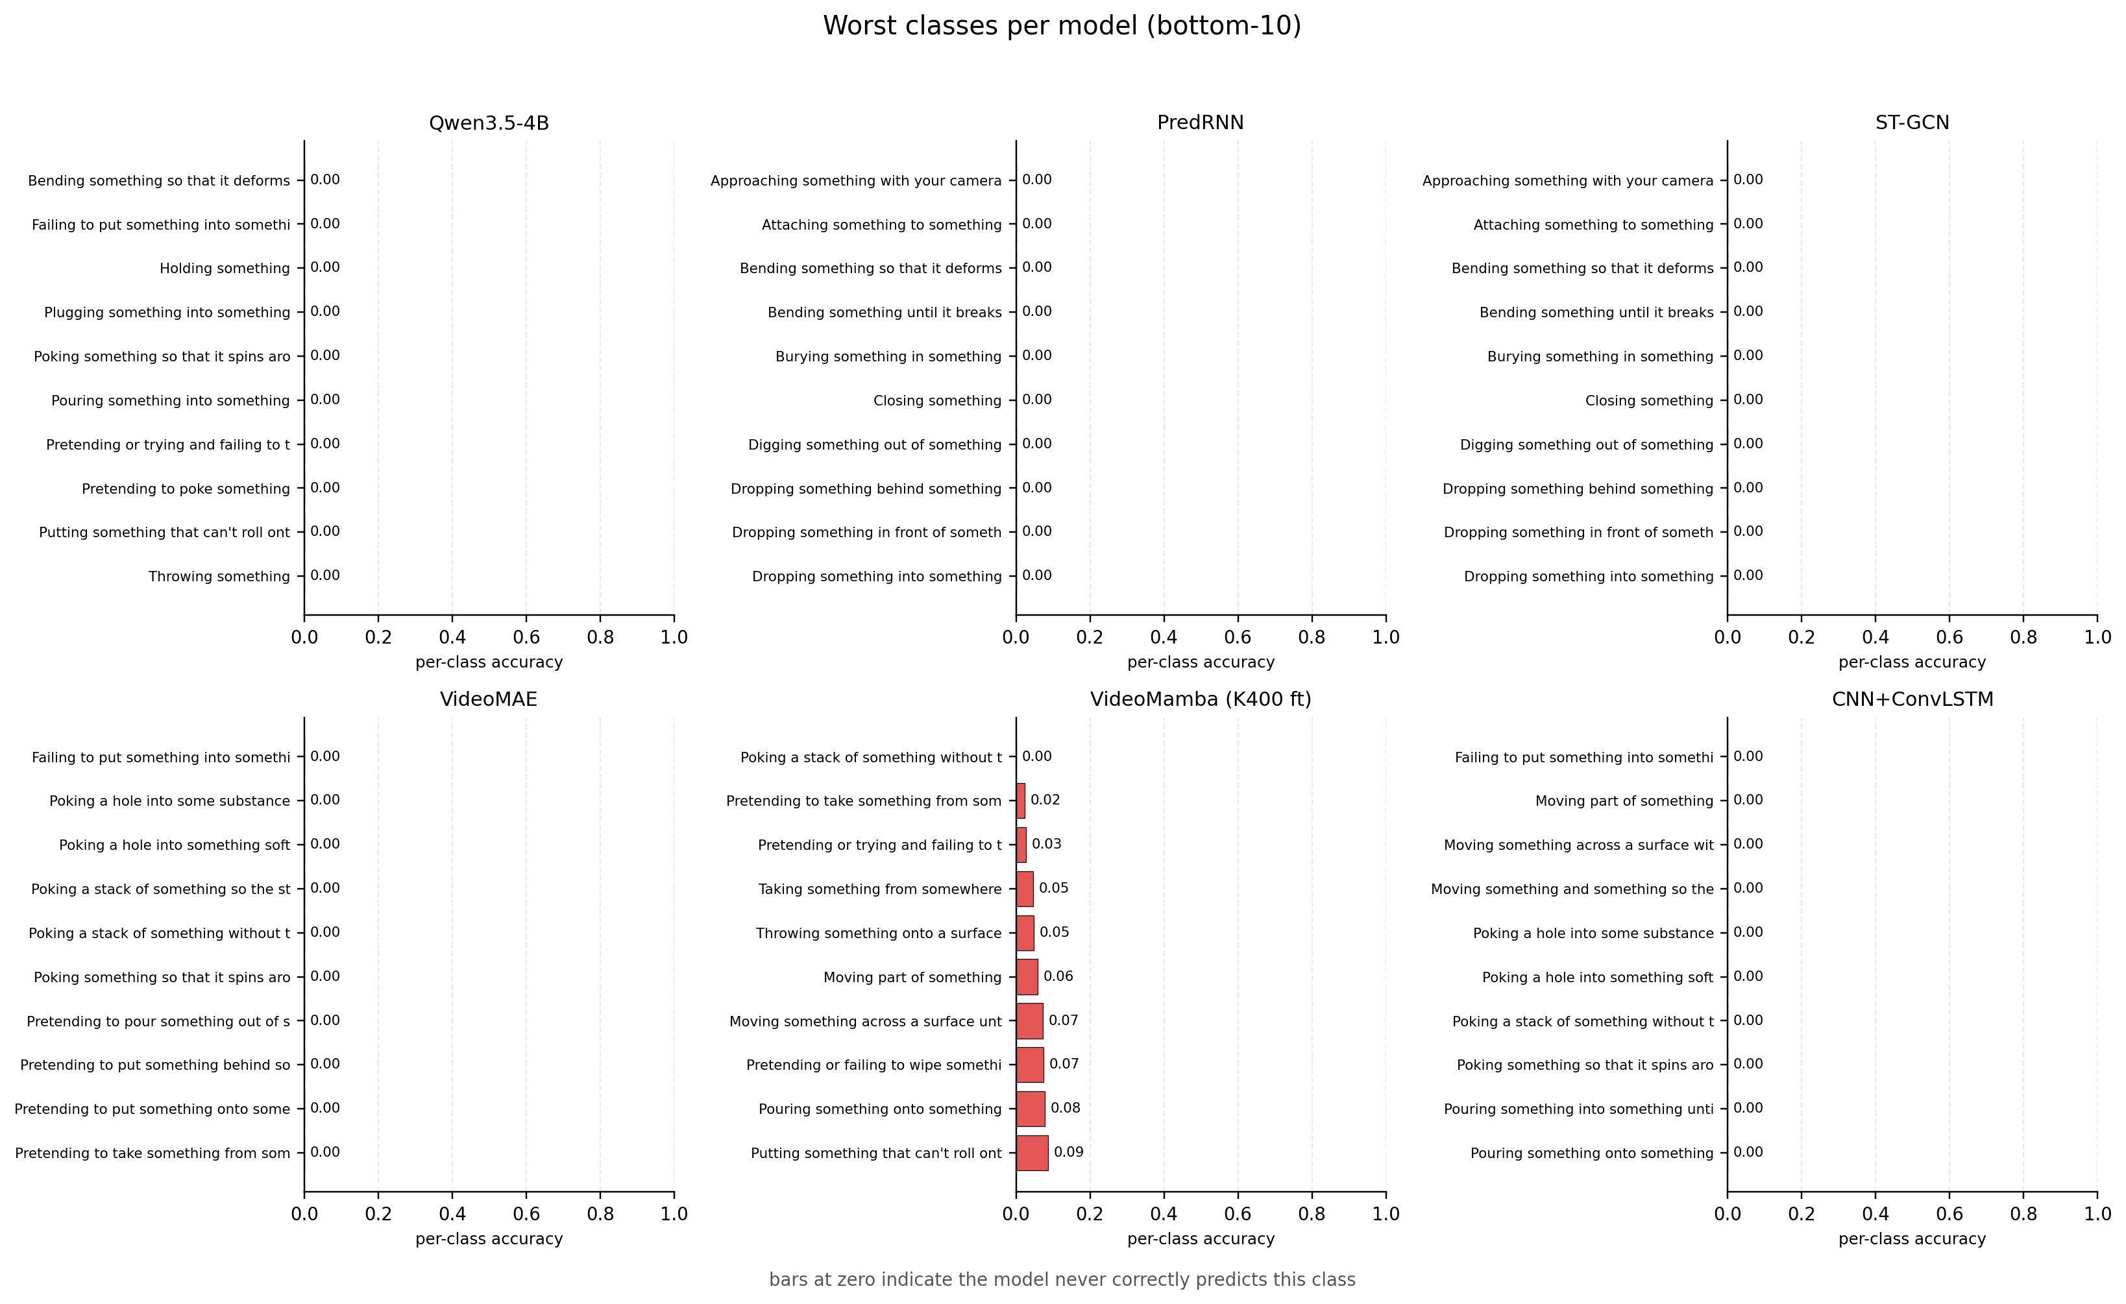
Figure 5: Worst classes per model
Looking at off-diagonal peaks across models makes the pattern explicit. Qwen's worst pair is "Plugging something into something" predicted as the same with a pull-out, 429 confusions, the single largest off-diagonal peak in the benchmark. The two actions are visually identical for the first half of the clip, so with 8 sampled frames (half of which fall before the disambiguating gesture) this is a coin flip even for a human. PredRNN confuses "Something falling like a rock" with "Moving something down" 95 times, which is semantically correct since falling is a kind of moving down; PredRNN learned the global motion direction but not the physical-state component. VideoMAE confuses "Tearing something just a little bit" with "Tearing something into two pieces" 57 times: same kinematics, different magnitude, and the magnitude signal is mostly gone from 16 frames at 224. R(2+1)D confuses "Removing something, revealing something behind" with "Moving part of something" 54 times because the hand motion is shared but the relational semantics (one object uncovered relative to another) aren't. TSM at 6.27% confuses "Moving something and something so they pass each other" with "Something colliding with something and both are being deflected" 7 times, which is essentially random behavior on a multi-object motion template.
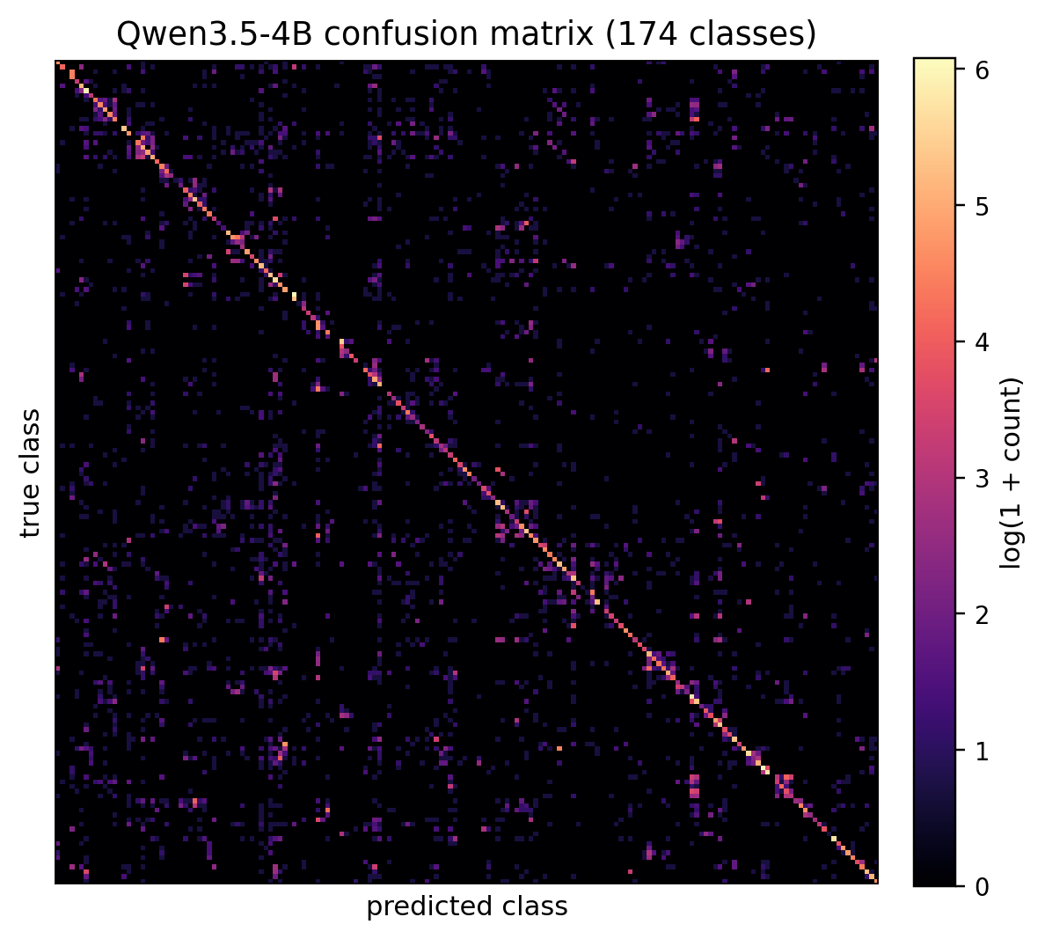
Figure 6: Confusion matrix, Qwen3.5-4B
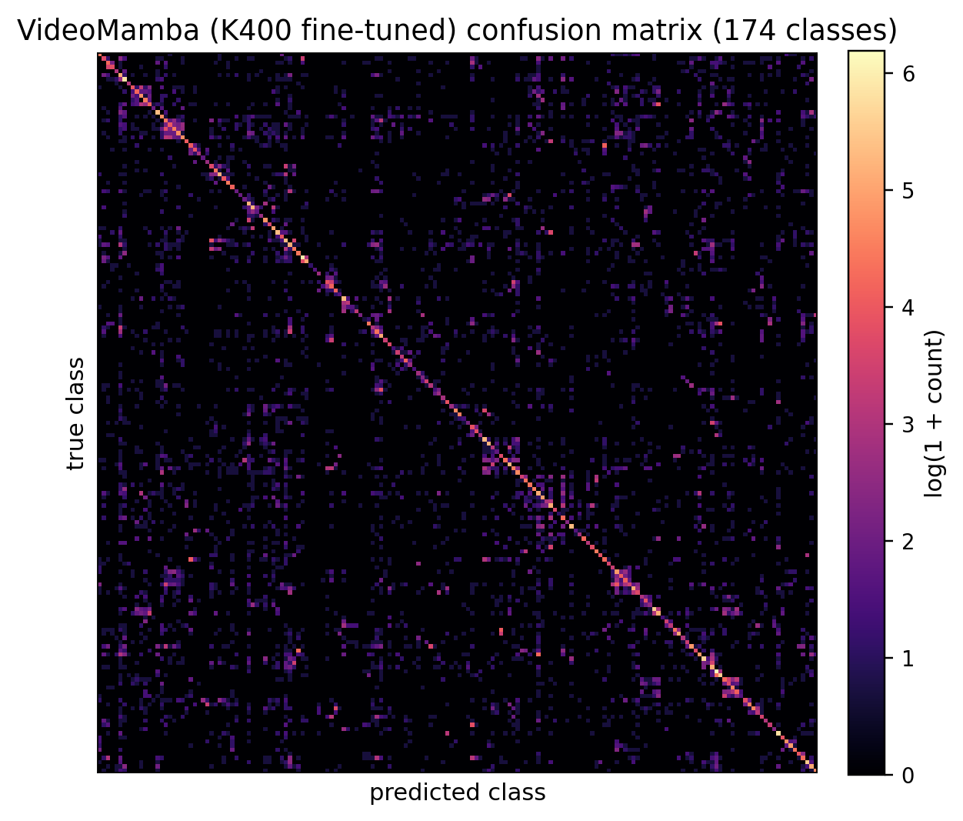
Figure 7: Confusion matrix, VideoMamba (K400 finetuned)
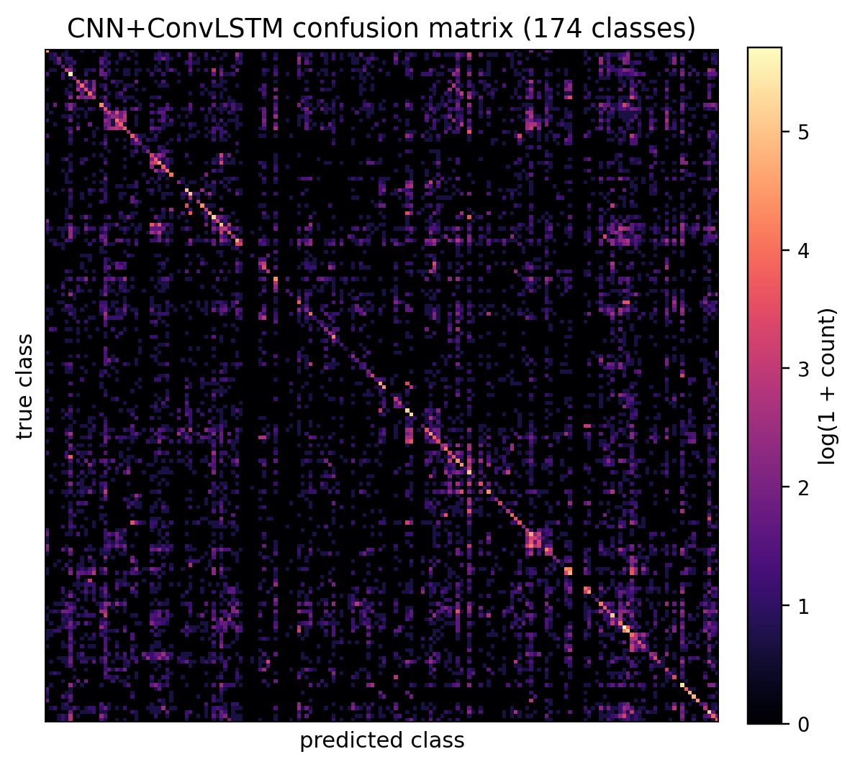
Figure 8: Confusion matrix, CNN+ConvLSTM
Every confusion pair above shares one feature: SSv2 trips up everyone on physical-state changes that go beyond visible motion. The label encodes a physical outcome (pulled out, fell, tore in half, uncovered, collided vs. passed) that's only weakly visible in 8 or 16 sampled frames. Even V-JEPA at 64.51% top-1 leaves over 35% of clips on the table with the same kinds of mistakes. On SSv2, once you're using a pretrained model, the architecture matters less than how good the pretraining was and how many frames you feed in. We come back to this in the discussion.

7. Discussion
Four threads run through the results, and they all point in the same direction.
Pretraining dominates architecture choice on SSv2. The top three models (V-JEPA 64.51%, Qwen 58.19%, post-bugfix VideoMamba 53.91%) are all pretrained on huge external corpora: V-JEPA on VideoMix2M, Qwen on internet-scale image-text, VideoMamba on Kinetics-400. R(2+1)D and SlowFast are Kinetics-pretrained and land in the upper-middle. CNN+ConvLSTM is partially pretrained (ImageNet ResNet-18 backbone, ConvLSTM head from scratch) and lands at 27.01%, in between. The from-scratch models sit at the bottom in a tight band: PredRNN 4.67%, ST-GCN 3.94%, pre-bugfix VideoMamba 1.45%. SSv2 is too hard for 18M-31M parameters trained on 168K clips to learn from zero, and architecture choice is a much smaller knob than pretraining choice on this dataset.
Correctness before speed. The from-scratch VideoMamba run used the bundled videomamba.py, which silently built a unidirectional model because bimamba=True was absorbed as an unused kwarg by mamba_ssm. Ten epochs gave 1.45%. We rebuilt a real Bimamba class with _b-suffixed forward and backward parameters matching OpenGVLab's released checkpoint, then loaded the K400 weights. Two epochs of the corrected model gave 53.91%, a 50-point delta on the same architecture name and same data, separated only by whether the bidirectional flag actually did anything. The corrected forward uses the explicit selective-scan path rather than the fused mamba_inner_fn kernel, costing about 3.5x throughput, but the explicit path keeps the parameter layout matching the checkpoint. When a flag is the difference between 1% and 54% top-1, verifying the flag is more valuable than any speed optimization.
Skeleton-only is the wrong bet for SSv2. ST-GCN is the "wrong dataset for the architecture" datapoint. MediaPipe found a usable skeleton in only 52.9% of train clips and 55.6% of val, because SSv2 shows hands on a tabletop, not full bodies. Even when a skeleton is detected, it cannot see the objects being manipulated. "Pouring until it overflows" and "Pouring" share arm trajectories, and the difference lives in the liquid level, not a joint. Skeleton models belong on Kinetics-style sports and dance datasets, not SSv2.
VLMs are surprisingly competitive. The Qwen QLoRA run is the unexpected result of the project. With 3.15M trainable LoRA parameters out of 2.59B (0.12%), one epoch reached 58.19%, six points below V-JEPA and four to twelve points above every dedicated video model except post-bugfix VideoMamba. We didn't tune the LoRA rank, didn't train more than one epoch, and used a fixed LR. For compute-constrained settings, this is the headline: a small adapter on a frozen quantized VLM, one epoch, beats a from-scratch 18M video model trained 15 epochs by 50+ points and a Kinetics-pretrained 31M 3D CNN trained 30 epochs by 12 points. Qwen also has the broadest per-class coverage, with only 10 of 174 classes at 0% (vs roughly 70% for PredRNN and 95% for ST-GCN). The ceiling is fine-grained physical-state distinctions, the same ceiling every other model hits.
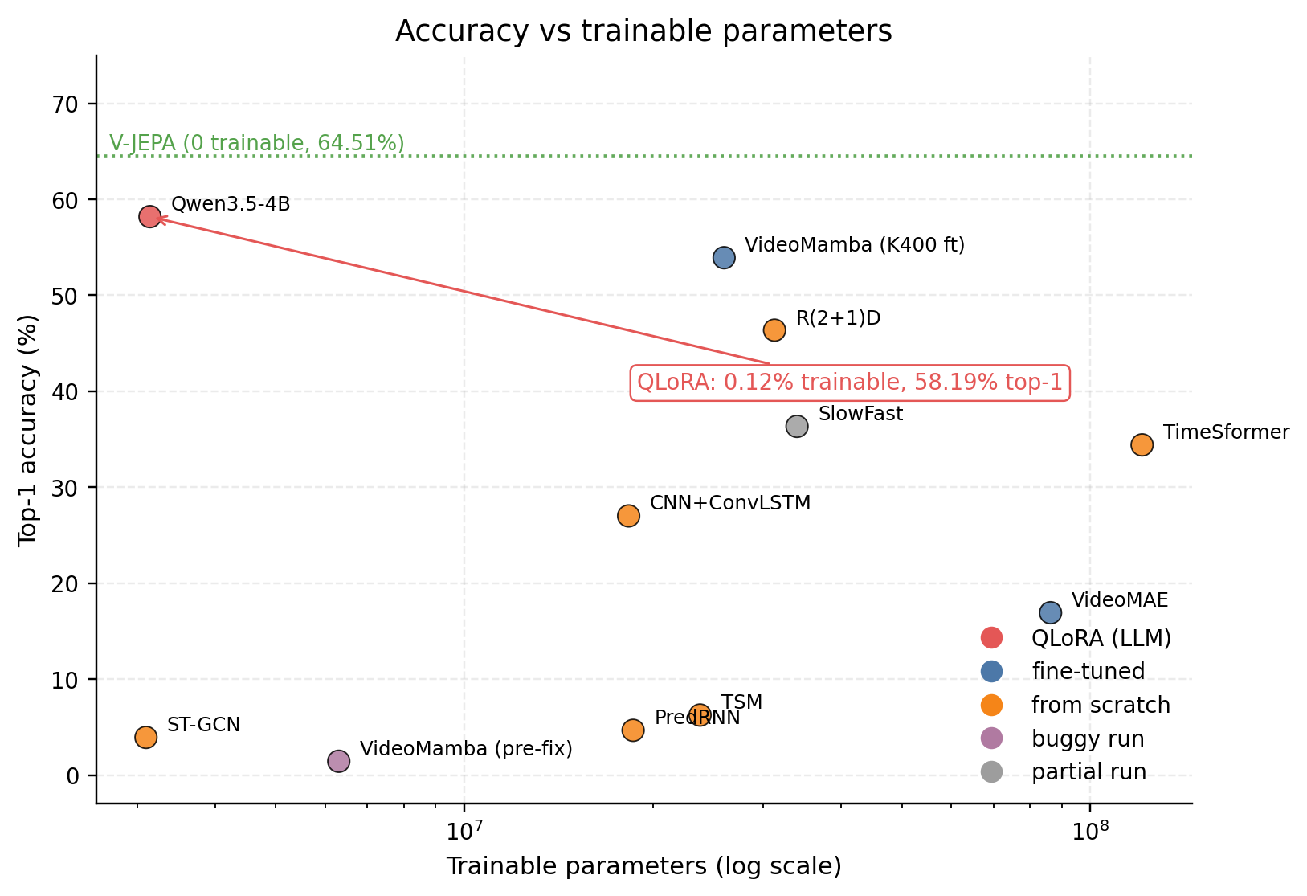
Figure 9: Top-1 vs trainable parameters

8. Software Tutorial
This section walks a new user from a bare machine to a running training job and a results JSON. Every model imports shared.get_dataloader for data and shared.evaluate.evaluate_model for metrics, so once you can run one you can run any of them.
Setup. Clone the repo and create the environment:
git clone https://github.com/munishbp/action-world-recognition.git
cd action-world-recognition
conda create -n cap5610 python=3.11 -y
conda activate cap5610
pip install -r requirements.txt --extra-index-url https://download.pytorch.org/whl/cu126
Python 3.11+ and CUDA 12.1+ are needed for the Blackwell-friendly PyTorch builds we used on the 5090. For exact reproducibility use requirements-lock.txt. VideoMamba additionally needs mamba-ssm (best on a real CUDA host with pip install mamba-ssm --no-build-isolation); the WSL workaround is in SETUP.MD.
Dataset. SSv2 is hosted by Qualcomm and mirrored on HuggingFace. Run python data/download_ssv2.py or follow SETUP.MD step 8 to pull HuggingFaceM4/something-something-v2. The layout under data/something-something-v2/ should be 1.webm, 2.webm, ..., plus an annotations/ folder holding the train (168,913 entries), validation (24,777), test (27,157), and labels (174 names) JSONs. Total disk footprint is around 20 GB of webm plus a few MB of JSON. The shared dataloader decodes webm on the fly with decord, but for the slowest paths (Qwen and VideoMAE both stalled on webm decode), pre-extract frames once with python data/cache_frames.py --split <train|val|test>. The script is resumable, and cached frames live under data/cache/ where the dataloader picks them up automatically.
Train. Every model has its own train.py invokable as a module. ST-GCN is the only one that needs a separate keypoint-extraction pass first since it consumes 33-joint pose tracks instead of RGB:
python -m models.tsm.train # 2D CNN with temporal shift, 30 epochs on a 5090
python -m models.qwen.train # VLM with QLoRA, 1 epoch on the full train split
python -m models.stgcn.extract_keypoints --split train
python -m models.stgcn.extract_keypoints --split val
python -m models.stgcn.train
Per-model flags are documented at the top of each train.py.
Evaluate and compare. Every training script calls shared.evaluate.evaluate_model automatically. Each run drops two artifacts into results/: a <MODEL>_results.json with top-1, top-5, F1, per-class accuracy, and metadata, plus a <MODEL>_confusion_matrix.npy with the 174x174 matrix. To re-evaluate from a checkpoint without retraining, use python -m shared.evaluate --predictions ... --labels ... --model-name TSM. The repo ships a one-screen snippet (in RESULTS.md) that loads every JSON and prints the headline metrics:
import json, glob
for f in sorted(glob.glob("results/*_results.json")):
r = json.load(open(f))
print(f"{r['model_name']:15s} top1={r['top1_acc']:.4f} top5={r['top5_acc']:.4f} f1={r['f1_weighted']:.4f}")
Running this from the repo root reproduces the Section 5 table. Confusion matrices in results/*_confusion_matrix.npy load with np.load(...) and feed the Section 6 off-diagonal-peak analysis. This is enough to reproduce every number, table, and figure on your own hardware.

9. Conclusion and Future Work
The headline is that pretraining beats architecture choice on SSv2 at any reasonable scale. The top three rows of our table (V-JEPA 64.51%, Qwen 58.19%, post-bugfix VideoMamba 53.91%) are three different families (frozen self-supervised ViT, quantized VLM with a LoRA adapter, fine-tuned bidirectional SSM), and what they share is heavy external pretraining. The bottom three rows (pre-bugfix VideoMamba, ST-GCN, PredRNN) are also three different families, and what they share is no pretraining at all. CNN+ConvLSTM sits between those two groups with an ImageNet ResNet-18 backbone and a from-scratch head. What pushed a model up the table was where its weights came from, not the shape of the model.
The other story is the project beat itself: the biggest result of the semester was a bug fix. The from-scratch VideoMamba run reached 1.45% over ten epochs because bimamba=True was silently absorbed by mamba_ssm and the layer was unidirectional. Two epochs of a corrected bidirectional model loaded from OpenGVLab's K400 checkpoint reached 53.91%, a 50-point delta on the same architecture name separated only by whether a flag did what its name said. Verifying critical flags is more valuable than any speed optimization.
We didn't run anything close to the full set of experiments these results suggest. The concrete next steps, in order of expected payoff: re-run V-JEPA on an A100 with native bf16 to recover the published 69.5% (the V-JEPA eval script hardcodes dtype=torch.float16 in its autocast block even when the config sets use_bfloat16: true, so our V100 run was actually FP16 and lost about 5 points of top-1 to softmax dynamic range, and patching the autocast block is roughly a one-day fix). Run a full 15-epoch VideoMamba with the fused mamba_inner_fn kernel: we stopped at 2 epochs because the explicit selective-scan path costs 3.5x throughput, but the trajectory was 50.13% at epoch 1 and 53.86% at epoch 2, monotonically climbing, and a conservative extrapolation puts 15 epochs in the 58 to 62% range. Try multi-modal fusion of ST-GCN skeleton features with R(2+1)D RGB features, since skeletons encode direction-of-motion cleanly (exactly where R(2+1)D struggles) even though they can't see manipulated objects. Train Qwen for three epochs instead of one, which would likely push past V-JEPA's 64.51% ceiling. And try a targeted curriculum on the "pretending" and physical-state classes that defeat every model, possibly with synthetic counterfactual clips, to test whether the failure is dataset balance or a real representational ceiling. Together these five items would close most of the gap between our numbers and the published numbers, and would turn the Qwen result into a decisive claim about VLMs as a default for compute-constrained video classification.

